St. Peter the Apostle School
15 Silver Birch Court
Parry Sound,
ON P2A 0A8
Phone: 705-746-7196
Fax: 705-746-5165
http://spe.schools.smcdsb.on.ca/

Principal: Mrs. Pender Office Administrator: Mrs. Hill
March Newsletter 2018

Principal’s Message

We are now in the Liturgical Season of Lent. Lent offers us all a very special opportunity to change our hearts and to grow in our relationship with God. In our busy world, Lent is an opportunity to slow down, reflect upon our way of life, to pray more deeply, to experience sorrow for our sins and to be generous to those in need. We are called to deepen our commitment to a way of life, which is rooted in Christ. Lent is a time of prayer, fasting and almsgiving. It is a beautiful season of returning to God, embracing His love and forgiveness.
At St. Peter the Apostle we are constantly striving to help our students become more concerned for each other and more attentive of others’ needs. We talk about effective conflict resolution with the goal of being able to be aware of and concerned for others through thoughts and feelings. We remind our students to ask themselves in every situation, “What would Jesus do?” and we encourage them to try to act with compassion and respect, as we know Jesus would.

May God Bless us,
Mrs. J. Pender

Trustee’s Message:

Be who God meant you to be and you will set the world on fire.
St. Catherine of Sienna

I had the pleasure of welcoming St. Dominic student Anna Szumska to the SMCDSB

Board table as our Student Trustee-elect. She joins our current Student Trustee,
McKenna McCoy, another St. Dom’s student, to bring the voice of our 21,000 students to our decisions.
As I reflected on the fact that 3 of our last 6 student trustees have come from St. Dominic, I thought about all of the opportunities DOMS students have to explore their leadership potential. In a small school, youth have the chance to take risks in a really
safe environment. I know my children benefitted from being Peer Support Workers and taking leadership roles on Student Council, when they may not have taken those chances in a larger school.
Parents have a lot of difficult decisions to make during their children’s teen years. I know that we didn’t always make the right ones, but we never regretted the decision to send our children to St. Dom’s. They formed lasting friendships and bonds with staff and students that have helped them to find success at university and in the careers they
followed after post-secondary. The amazing staff, small class sizes, leadership opportunities and Catholic curriculum helped them develop into caring adults.
I look forward to hearing more great ideas from our Student Trustees as they represent the SMCDSB student voice!
God Bless,
Carol Corriveau-Truchon

Wanted! 2018-2019 Kindergarten Registrations
It’s Kindergarten Registration Time again! (Packages are available at the office, please call Mrs. Hill.)
Welcome to Kindergarten
Starting Kindergarten is an exciting and special time for parents and children. Our entire Catholic school
Community looks forward to welcoming our youngest students as they begin a lifelong journey of faith-filled learning. We believe there is something truly unique and special about learning that is rooted in faith and spiritual growth. By choosing a faith-filled education, we know you will share that belief with us.
All the Information You Need
To help parents and students get ready for this important milestone, our board has developed an award-winning package. We encourage parents who are looking to register their child for Kindergarten to drop by the office to pick up their copy of the package, which includes a parent booklet, child’s activity book. You can also find all of the information on our board’s website at www.smcdsb.on.ca/families/kindergarten
English as a Second Language (ESL)
We have resources and information available for families whose first language is not English. Please inquire about the ESL version of our Kindergarten package. We are here to answer questions and help you prepare. Please contact the office for more information (705) 746-7196.

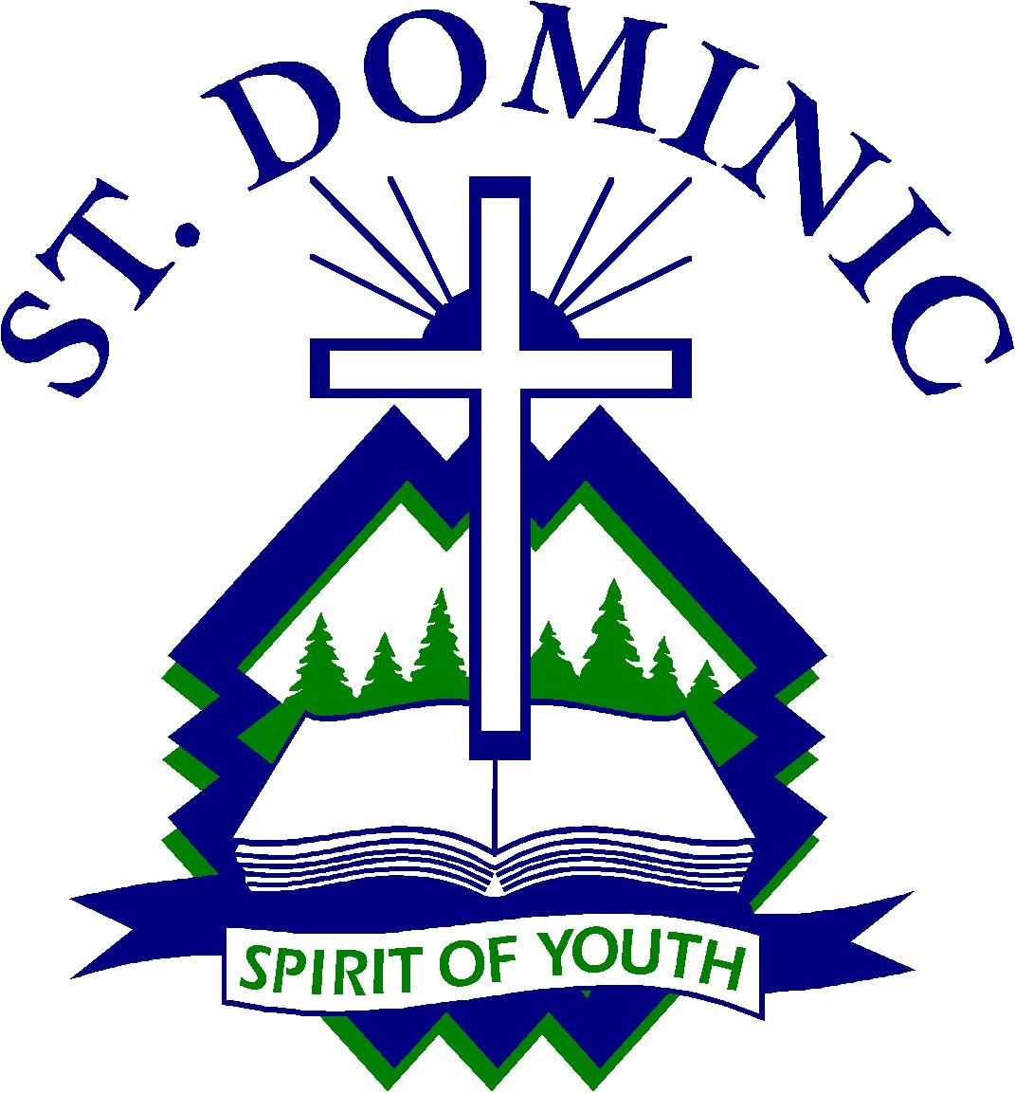
St. Dominic Registration (Open-access)
St. Dominic Catholic Secondary School has sent home Grade 8 Registration packages. Extra packages are available in the office should they be required. Please help to spread the word that all publicly funded secondary schools are considered to be “open-access” in Ontario. This means that students from both the Catholic and public boards can register at St. Dominic.

Math tips to help your child at Home:

Doing Mathematics with your Child (K-6) - Parent booklet. Please click on the link below ( translations available ) to be directed to fun math ideas to help your child at home.
Many translations available
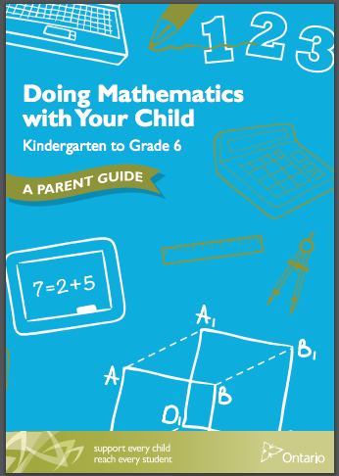

Food Drive

Students are asked to please bring non-perishable food items to help with our Lent Food Drive. The donations will be given to the ‘Harvest Share’ as the needs in the Parry Sound and surrounding area are increasing. Lets all do our part and help with a good cause!

Little Caesar Pizza Kit Fundraiser

We have begun our second Little Caesar pizza Kit Fundraiser. The proceeds will go towards the following: offsetting the cost of field trips and bussing, new books for the library, gym equipment, and technology. Thank you for your support!

Health News
Help stop the spread of sickness. If your child/ren are experiencing any of the following symptoms, fever, vomiting, diarrhoea, or flu, it is recommended that the child should be 24 hours free of symptoms before returning to school. Sending your child back too soon only infects others in the school. Thank you!

Catholic School Community Council (CSCC):

The Catholic School Community Council meets to discuss school issues. Our objective is to provide a caring, nurturing, educational environment steeped in the Catholic tradition. All parents are welcome to attend. Our next CSCC meeting is Wednesday, February 28th @ 6:00 pm, Weather permitting.
For more information, please email Karina Lapping at karinalaping@hotmail.com or call Mrs. Hill in the office. New Parents are always welcome! Children are also welcome to come and go on the computers in the library while parents meet and discuss various items.

School Mass:
Our next school Mass will be held on Thursday, March 1st at 9:30 am in the gymnasium. Everyone is always welcome to come and celebrate with us!

Lunch Clubs Happening at SPE

Chess Club:

Students in Grades 4-8 are invited to join the Chess Club. Practices will take place on Thursdays in the library. Please remind your students that commitment and practice is important! The Chess tournament will take place on April 26th at the BOCC. More information will come out closer to the date.

Robotics Coding Club:

Students in Mrs. Madden’s Grade 6/7 class are invited to join the Coding Club and learn how to Code with Dash & Dots. The Coding Club meets every Wednesday in the library for the month of March and April. The next class will be Mrs. Bunker’s Grade 8 class for months of May & June!

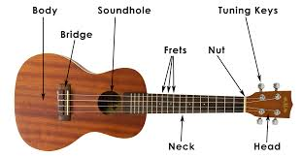

Ukulele Club

Students are invited to join the New Ukulele Club and learn how to play. This Club is happening in the Music Room on Fridays at 12:05 pm with Mr. Howard. Students are asked to bring in their own Ukulele, so that they can practice each night at home!

School Skating:
Our last school skating session will be held on Thursday, March 8th, 2018 at the Bobby Orr Community Centre. Parents are always welcome to come and enjoy the fun!

We appreciate your help with tying skates too!
JK/SK – Grade 3 1:30 pm - 2:10 pm
Grades 4 –8 2:10 pm - 2:50 pm

Inclement Weather
Bus cancellation announcements can be heard on 103.3
Moose FM or viewed on our board website at
www.smcdsb.on.ca. We are in the West Parry Sound Region. When buses are cancelled in other regions of our Board because of inclement weather, they may not be cancelled for us! In the coming months, please remember to listen for weather zones, when buses are cancelled. Please note that the school will not be phoning home to advise you of any bus cancellations. In the event that the buses are cancelled, the school is open for learning. Drop off time is 8:35 a.m. and pick up time is 3:10 pm. If the inclement weather day is a pizza or hot dog day, the food is cancelled and will be delivered the following day. Milk will continue as usual but your child will need to bring a lunch.

