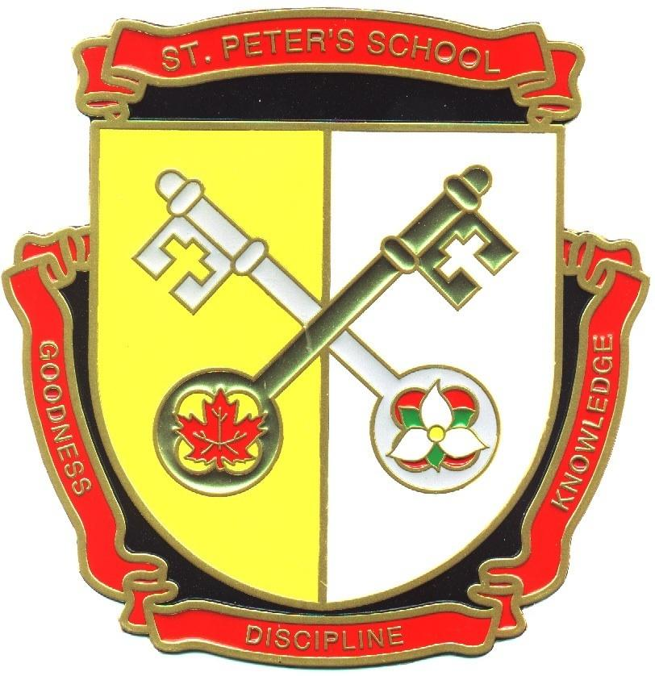
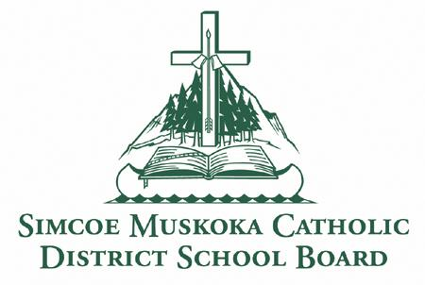
St. Peter the Apostle School
15 Silver Birch Court
Parry Sound,
ON P2A 0A8
Phone: 705-746-7196
Fax: 705-746-5165
http://spe.schools.smcdsb.on.ca/

Principal: Mrs. Pender Office Administrator: Mrs. Hill
January Newsletter 2018

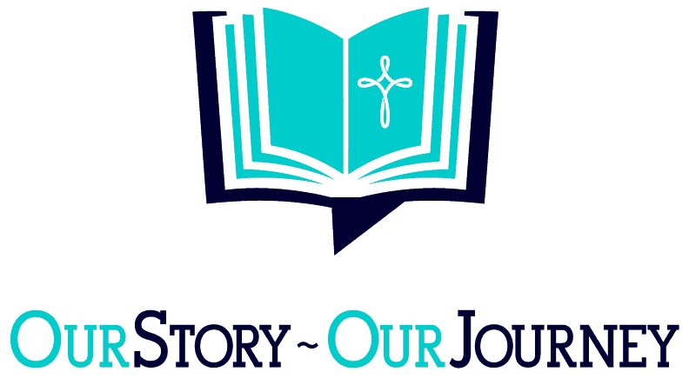

Principal’s Message

You will find a baby wrapped in swaddling clothes and lying in a manger.
Luke 2:12

January tends to be a time for goals, resolutions, renewed commitments and self-improvement. Some might even say fresh starts, but really, experiences and choices from our past serve to shape us into what we are today and what we can become moving forward.
Taking the best of our many past successes, and learning from the odd bump in the road from days gone by, is the age-old progression of human growth and development.
Gaining from our experiences, whether fantastically successful, or dreadfully disastrous is the true hallmark of learning. Students will return to class January 8, 2018 and will begin the journey toward June.

Thank you to everyone who attended our Christmas concert performance and visited the Book Fair. We deeply appreciate families making the time and commitment to celebrate both the season, and our students' efforts.
On a far more personal note, we want to thank everyone for their remarkable generosity during the holiday season, and we hope that 2018 sees your dreams become reality and the New Year brings you and your family peace, happiness, prosperity and good health. We look forward to welcoming everyone back on the 8th of January!

May God Bless,
Mrs. J. Pender

2018-2019 Kindergarten Registration
It’s getting close to Kindergarten Registration Time again! (Packages will be available February 1st 2018)
Welcome to Kindergarten
Starting Kindergarten is an exciting and special time for parents and children. Our entire Catholic school
Community looks forward to welcoming our youngest students as they begin a lifelong journey of faith-filled learning. We believe there is something truly unique and special about learning that is rooted in faith and spiritual growth. By choosing a faith-filled education, we know you will share that belief with us.
All the Information You Need
To help parents and students get ready for this important milestone, our board has developed an award-winning package. We encourage parents who are looking to register their child for Kindergarten to drop by the office to pick up their copy of the package, which includes a parent booklet, child’s activity book. You can also find all of the information on our board’s website at www.smcdsb.on.ca/families/kindergarten
English as a Second Language (ESL)
We have resources and information available for families whose first language is not English. Please inquire about the ESL version of our Kindergarten package. We are here to answer questions and help you prepare. Please contact the office for more information (705) 746-7196.

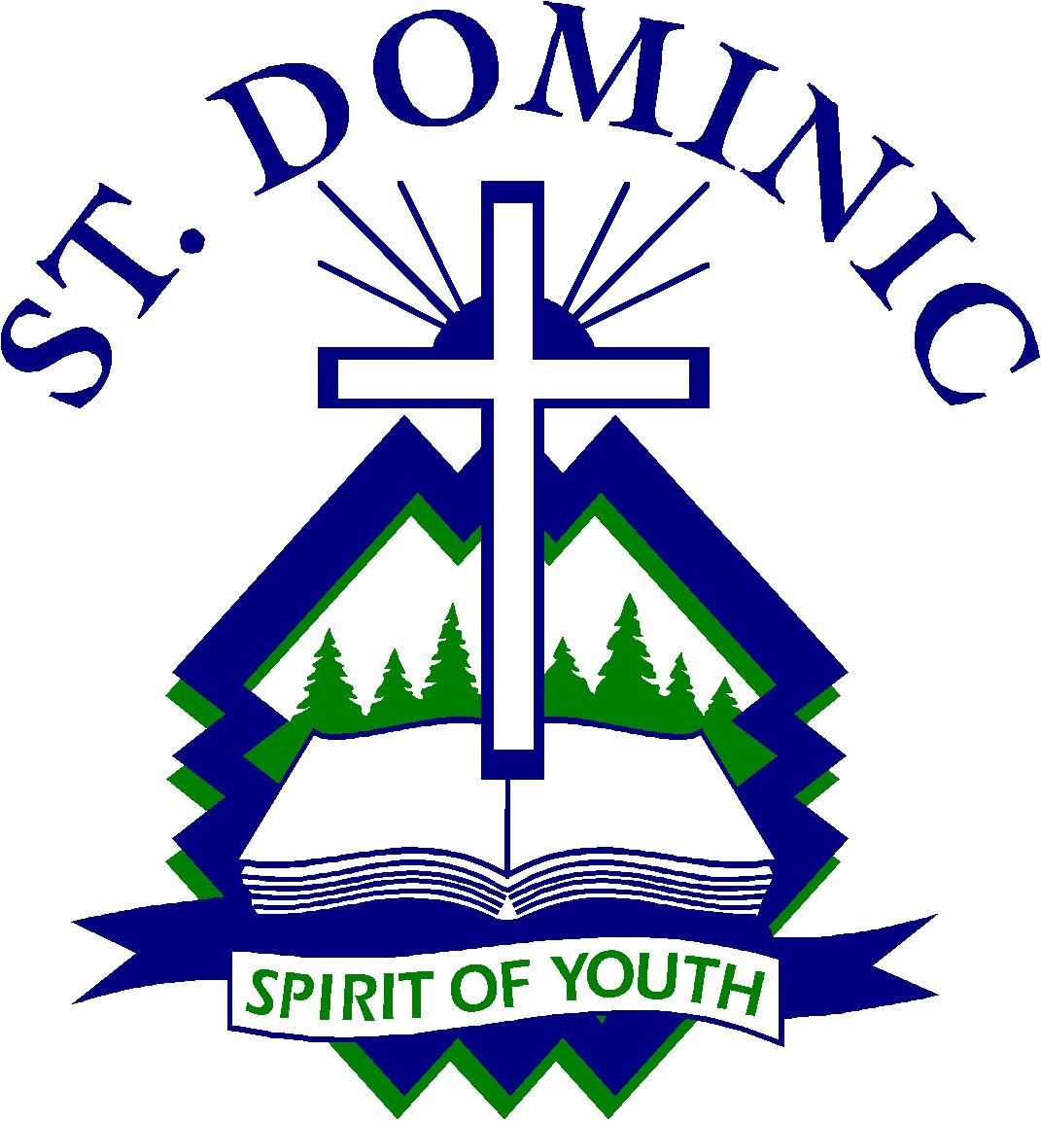
St. Dominic Registration (Open-access)
St. Dominic Catholic Secondary School has sent home Grade 8 Registration packages. Extra packages will be available in the office should they be required. Please help to spread the word that all publicly funded secondary schools are considered to be “open-access” in Ontario. This means that students from both the Catholic and public boards can register at St. Dominic.

Warm Clothing
Please ensure that your child is dressed appropriately for the weather conditions throughout the day. Hat, mitts or gloves, snow pants and boots are necessary when the snow starts to arrive. Putting an extra set of mittens and socks in school bags is highly recommended. Please label all clothing items so that we can easily identify to whom the items belong. If you need assistance to attain these items, please contact the school. We have graciously had a donation from the Knights of Columbus of girls and boys winter jackets. If any family is in need, please contact the office, we are here to help! We would also appreciate any donations of hats, mitts and scarves for our school “borrow and bring back program” for students who may be in need of these items.

Catholic School Community Council (CSCC):

The Catholic School Community Council meets to discuss school issues. Our objective is to provide a caring, nurturing, educational environment steeped in the Catholic tradition. All parents are welcome to attend. Our next CSCC meeting is Tuesday January 9th @ 6:00 pm, Weather permitting.
For more information, please email Karina Lapping at karinalaping@hotmail.com or call Mrs. Hill in the office. New Parents are always welcome! Children are also welcome to come and go on the computers while parents meet and discuss various items.

School Mass:
Our next school Mass will be held on Thursday. January 11th at 9:30 am in the gymnasium. Everyone is welcome to celebrate with us!

Chess Club:

Students in Grades 4-8 are invited to join the Chess Club. Practices will take place on Thursdays in the library. Please remind your students that commitment and practice is important! The Chess tournament will take place on April 26th at the BOCC. More information will come out closer to the date.

Robotics Coding Club:

Students in Mr. Skinner’s Grade 5/6 are invited to join the Coding Club and learn how to Code with Dash & Dots. The Coding Club meets every Wednesday in the library for the month of January and February. The next class will be Mrs. Madden’s Grade 6/7, for March & April, followed by Mrs. Bunker’s Grade 8 class for May & June!

Curling Bonspiel

Students in Grade 4-8 are invited to join the Curling Club that we have going on at the Parry Sound Curling Club. A big thank you to Mrs. Forder for helping run this! Students that are interested in joining the Curling Club are asked to contact the office.

School Skating:
Our next school skating session will be held on Thursday, January 11th, 2018 at the Bobby Orr Community Centre. Parents are welcome to come and enjoy the fun!

We appreciate your help with tying skates too!
JK/SK – Grade 3 1:30 pm - 2:10 pm
Grades 4 –8 2:10 pm - 2:50 pm

Inclement Weather
Bus cancellation announcements can be heard on 103.3
Moose FM or viewed on our board website at
www.smcdsb.on.ca. We are in the West Parry Sound Region. When buses are cancelled in other regions of our Board because of inclement weather, they may not be cancelled for us! In the coming months, please remember to listen for weather zones, when buses are cancelled. Please note that the school will not be phoning home to advise you of any bus cancellations. In the event that the buses are cancelled, the school is open for learning. Drop off time is 8:35 a.m. and pick up time is 3:10 pm. If the inclement weather day is a pizza or hot dog day, the food is cancelled and will be delivered the following day. Milk will continue as usual but your child will need to bring a lunch.

