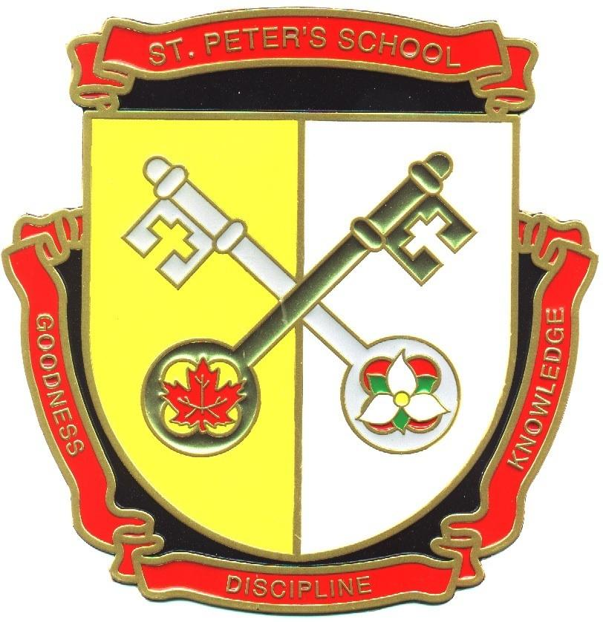
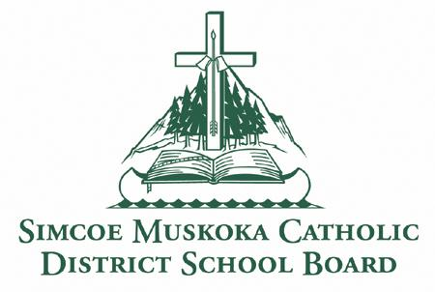
St. Peter the Apostle School
15 Silver Birch Court
Parry Sound,
ON P2A 0A8
Phone: 705-746-7196
Fax: 705-746-5165
http://spe.schools.smcdsb.on.ca/

Principal: Mrs. Pender Office Administrator: Mrs. Hill
December Newsletter 2017

Welcome to St. Peter the Apostle, a Catholic learning community dedicated to excellence!
Our Board’s theme for the year is
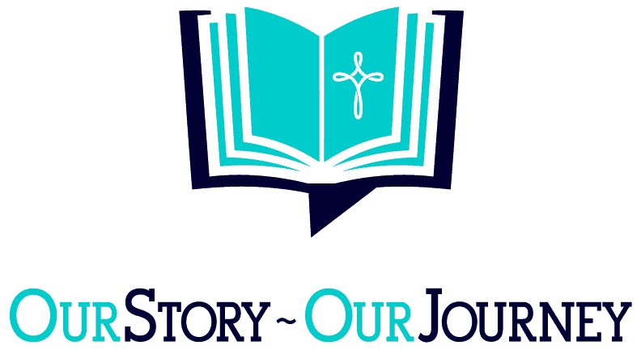

December Advent Prayer
Father, in the wilderness of the Jordan you sent a messenger to prepare people's hearts for the coming of your Son. Help me to hear his words and repent of my sins, so that I may clearly see the way to walk, the truth to speak, and the life to live for Him, our Lord Jesus Christ. Amen.

Principal’s Message

The first three months of school have flown by and we're only three weeks away from the holidays. The abruptness of winter is beginning to settle in as we enter into December. It is a time for explaining to children that the true gift of the holiday season is giving and caring for others.
This month the community of St. Peter the Apostle Catholic School is working on 'Hope' so it is the perfect time for the entire school community to role-model and express the following: Being Kind, Being Compassionate and Showing You Care, Expressing Gratitude, Forgiving Others and Helping People in Need.
I genuinely hope that you take the time to enjoy the holiday season with your family and friends. Sometimes, it can be a very exciting and hectic time of the year and we need to remember to slow down and relax.

A quote to think about:

May you have the gladness of the holiday season, which is hope; The spirit of the holiday season which is peace; The heart of the holiday season which is love. ~Ada V. Hendricks

Have a Merry Christmas!
Mrs. Janis Pender

Trustee’s Message

You will find a baby wrapped in swaddling clothes and lying in a manger.
Luke 2:12
The Association of Catholic Bishops of Ontario have issued a couple of pastoral letters on the subject of Catholic Education. The first, from 1989, was titled “This Moment of Promise” and the second in 1993, “Fulfilling the Promise”. The third pastoral letter will be published in 2018 and will be called “Renewing the Promise”. You may remember being asked to participate in a process of gathering information about the current strengths and challenges to Catholic Education last spring. Catholics from across the province were asked to answer some questions in the first round. That information was collated and then in round two, we were asked to indicate which we thought were most important.

In November, each Catholic School Board in the province was invited to send a team of 14 people to a Symposium in Toronto. Each team included: parents, teaching staff, union reps, principals, vice principals, the director, student trustees and the Board Chair. We were also joined by many of Ontario’s bishops, including Bishop Miehm. Throughout the day we spent time in our school groups and then in groups where we were mixed in with a cross-section of people from other groups.

There were so many great discussions around the room and ideas on how to build on the wonderful system that we currently have. I look forward to meeting with the committee again in the new year to discuss how we will implement some of the great ideas in our schools, and to the publication of the Bishop’s pastoral letter.

I hope to see many of you at Christmas Masses and Concerts this month. It is always so much fun to witness the joy and excitement of children at this time of year!

Merry Christmas!
Carol Corriveau-Truchon

Christmas Concert and Scholastic Book Fair
Save the date! Our Christmas concert will be held on Wednesday, December 13th in the evening (Inclement weather date is Dec. 14th). We look forward to showcasing our talents during Advent. Concert times are as follows:
JK - Gr.3 6:00 – 6:45 pm
Gr. 4 - 8 7:00 – 7:45 pm
The Book Fair arrives Dec. 6th and leaves Dec. 15th The book Fair will be in our newly organized library. Students can visit the Book Fair with their class from 2:10-3:00 during their normal library times. The Book Fair will also be open during the night of the Christmas Concert from 5:30-7:45 pm.

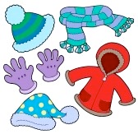
Warm Clothing
Winter officially arrives on December 21st. Please ensure that your child is dressed appropriately for the weather conditions throughout the day. Hat, mitts or gloves, snow pants and boots are necessary when the snow starts to arrive. Putting an extra set of mittens and socks in school bags is highly recommended. Please label all clothing items so that we can easily identify to whom the items belong. If you need assistance to attain these items, please contact the school. We have graciously had a donation from the Knights of Columbus of girls and boys winter jackets. If any family is in need, please contact the office, we are here to help! We would also appreciate any donations of hats, mitts and scarves for our school “borrow and bring back program” for students who may be in need of these items.

School begins at 8:50 am. Yard supervision is in place from 8:35 am to 8:50 am. For safety reasons, please do not drop off students prior to this time. Students are reminded to enter the schoolyard at the beginning of the day. Students arriving after 8:55 am will be required to have their parent/guardian sign them in at the office.

Catholic School Community Council (CSCC):

The Catholic School Community Council meets regularly to discuss school issues. Our objective is to provide a caring, nurturing, educational environment steeped in the Catholic tradition. All parents are welcome to attend. The next CSCC meeting is Tuesday December 13th @ 6:00 pm
For more information, please email Karina Lapping at karinalapping@hotmail.com or call Mrs. Hill in the office. Parents are always welcome!

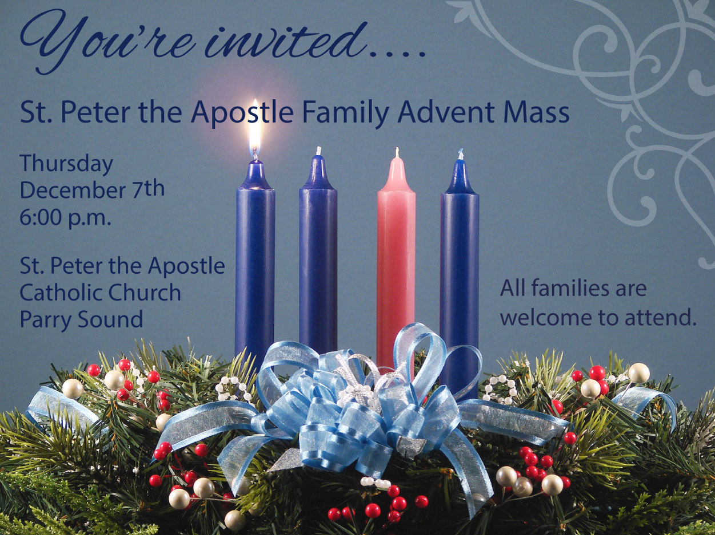
Family Advent Mass:
Our next church Mass will be held on Thursday December 7th at 6:00 pm at St. Peter the Apostle Church. Everyone is welcome to celebrate with us for fellowship and Hot Chocolate and cookies after mass!

Communication of School Events:
We do our very best to keep you informed of school activities and events. Parents are encouraged to read our monthly newsletters so that they can be informed of upcoming events. The monthly newsletter, is emailed out each month. Please remember to sign up for the newsletter and all other e-blasts by visiting the school website http://spe.schools.smcdsb.on.ca/. If you would like to receive a paper copy, please contact the office.
Paperless Newsletters:
In an effort to reduce paper consumption, we are encouraging families to choose to receive the monthly school e-newsletter, instead of a paper version. If you are interested in receiving the school newsletter via email, please go to our school website to sign up http://spe.schools.smcdsb.on.ca/
You can also contact the office and Mrs. Hill will help you with this. Thank you for supporting our efforts to go green!

School Skating:
Our next school skating session will be held on Thursday, December 7th, 2017 at the Bobby Orr Community Centre. Parents are welcome to come and enjoy the fun!
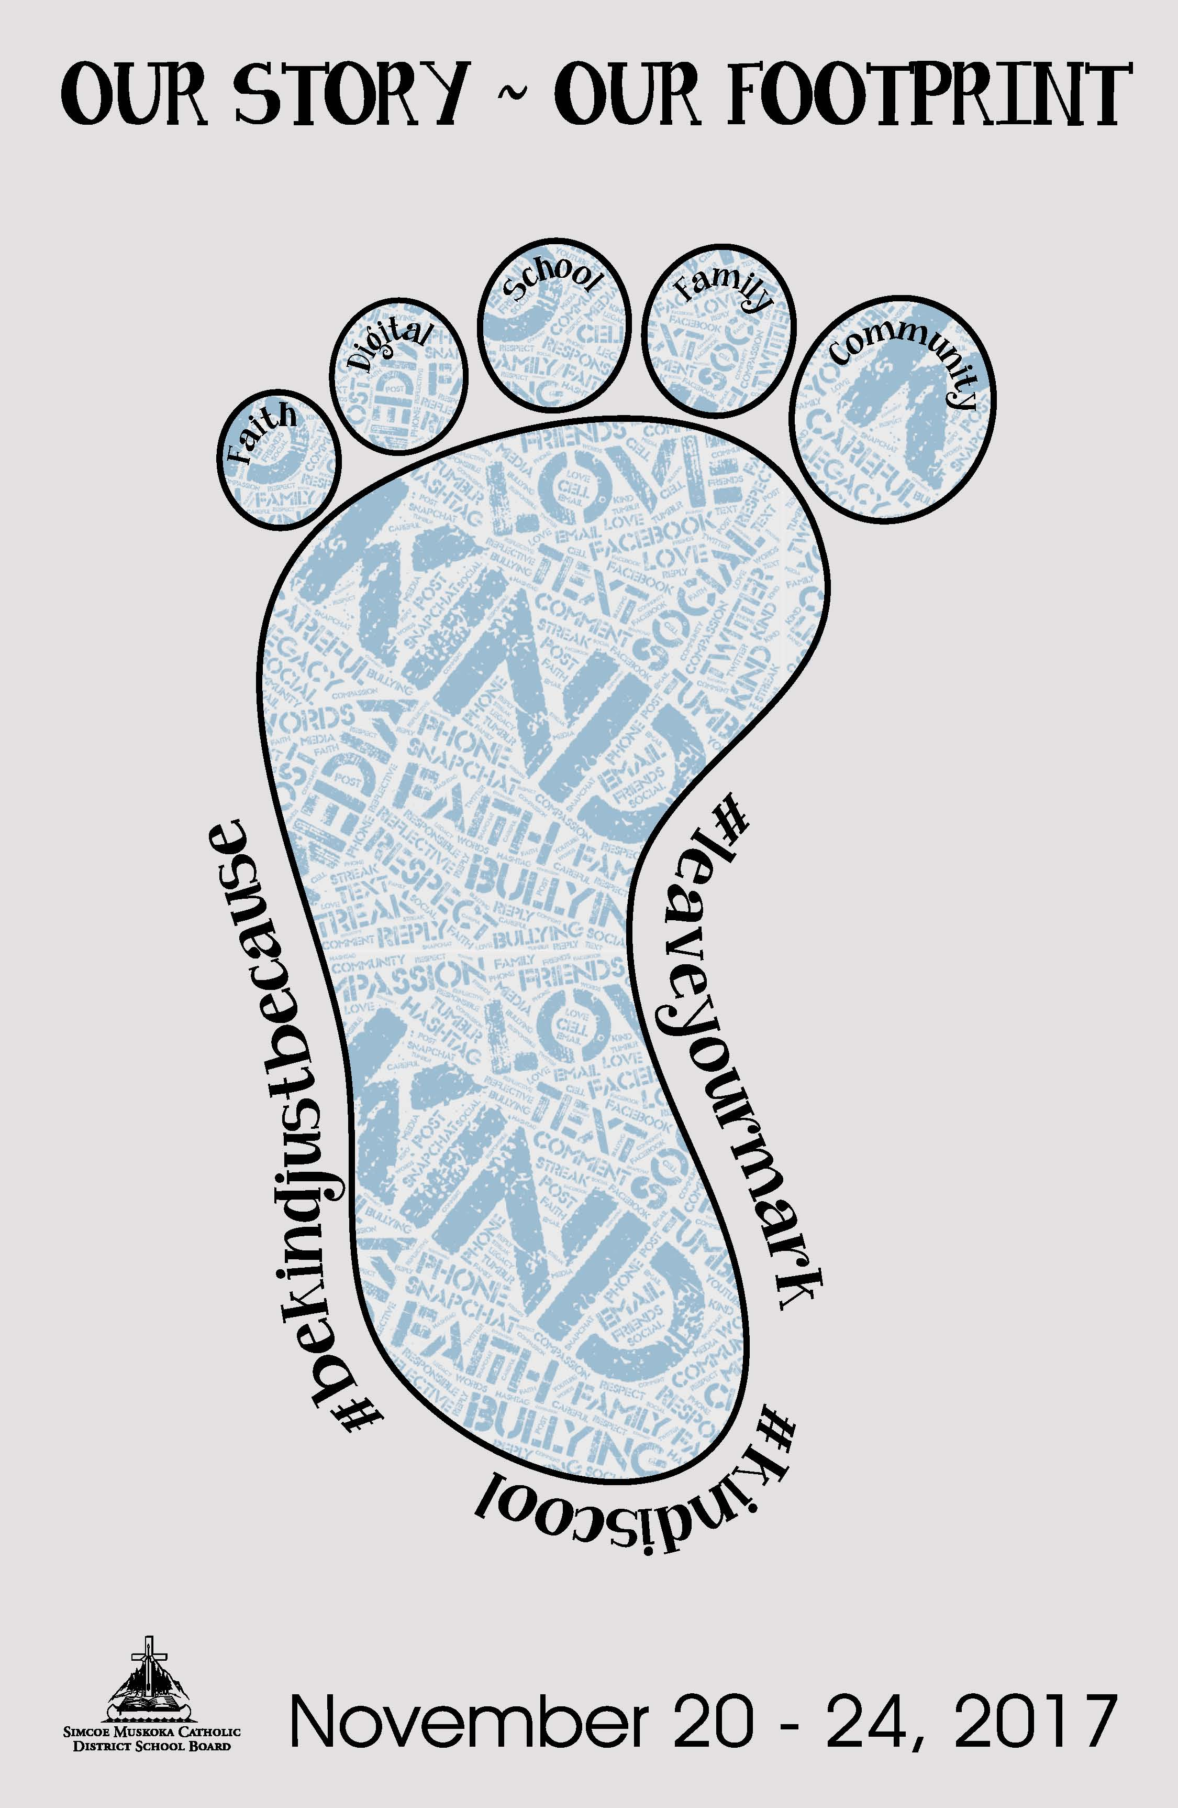
It was wonderful to see so many
parents/guardians at the rink last year. We appreciate your help with tying skates too!
JK/SK – Grade 3 1:30 pm - 2:10 pm
Grades 4 –8 2:10 pm - 2:50 pm

There are quite a few Lost and Found items outside of the office displayed on a table. Parents are asked to remind their child to look through the table and claim any lost items. All items not claimed by December 21st will be taken to the Salvation Army.

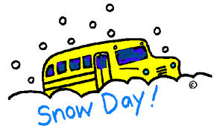

Inclement Weather
Bus cancellation announcements can be heard on 103.3
Moose FM or viewed on our board website at
www.smcdsb.on.ca. We are in the West Parry Sound Region. When buses are cancelled in other regions of our Board because of inclement weather, they may not be cancelled for us! In the coming months, please remember to listen for weather zones, when buses are cancelled. Please note that the school will not be phoning home to advise you of any bus cancellations. In the event that the buses are cancelled, the school is open for learning. Drop off time is 8:35 a.m. and pick up time is 3:10 pm. If the inclement weather day is a pizza or hot dog day, the food is cancelled and will be delivered the following day. Milk will continue as usual but your child will need to bring a lunch.

Anti-Bullying Assembly
Students participated in an Anti-Bullying assembly on November 20th where students were reminded of how to be a friend and how to stand up for themselves and for someone else. Our motto this year is Be Kind…Always!

